- netstate -ano -> get all opened ports
- ipconfig -> to know your logical IP Adress
- Ping [Ip Address] -> to know if this machine is working or Not
- telnet [Ip Address] [Port Number] -> to make sure if this port is opened on this machine or not.
- tracert www.google.com -> get all hops passed by them until reach to the final destination.
-------------------------------------------------------------Examples-------------------------------------------------------------
How to Kill process associated with Port in windows?
- C:\>netstat –ano
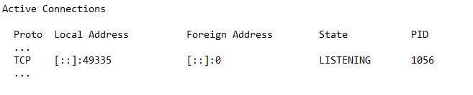
- C:\>tasklist /fi "pid eq 1056”
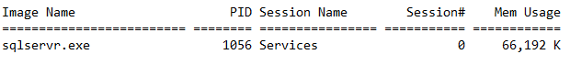
- taskkill /PID 827

